PRIVATISATION PROSPECT OF GEODESY AND CARTOGRAPHY ENTERPRISES OF THE RUSSIAN FEDERATION
Alexander V.Borodin
The Ministry of transport of the Russian Federation
109012, Moscow, street Rozhdestvenka, h.1, b.1
BorodinAV@mintrans.ru

Federal State Unitary Enterprise (FGUP) Roskartographia constitutes a network of regional enterprises functioning in the country as an interrelated production and economic body.
Operations of FGUP Roskartographia are managed by the Federal Agency of Geodesy and Cartography. The unified system of Roskartographia in the Russian Federation consists of 19 regional bodies of Roskartographia and 36 FGUPs of Roskartographia. The sector structure includes an optical and mechanical plant, large aerogeodetic and mine surveying enterprises as well as research establishments.
Today, enterprises of Roskartographia cover all sectors in the jurisdiction of the Russian Federation in the field of geodesy and cartography. Their primary activities include carrying-out a package of prospecting, survey, cartographic, topographic works and underground survey in the whole territory of the Russian Federation, providing governmental authorities, local authorities, legal entities and individuals with geodetic and cartographic materials and data, furnishing them with reliable information on locations in graph, digital, photographical (included on the basis of geometrical sounding of the Earth using aerospace methods) and other forms.
The existing restrictions of converting enterprises of Roskartographia into joint stock companies needs a substantial review due to the fact that organisations performing all or part of the functions of state organisations or rendering similar services to consumers have been operating in the Russian market successfully and for a long time.
It should be noted that a wider notion of the geodesy and cartography sector should also include private geodetic and cartographic enterprises and higher educational institutions training appropriate specialists as well as enterprises subordinate to other governmental authorities.
It became possible to discuss the issue of converting state-owned enterprises of the sector into joint stock companies after it became clear that the enterprises had become DIFFERENT, built in the country’s common market of cartographic and geodetic production. Today, there is no need to discuss the issue of survival, retention and stabilisation of the state-owned part of the sector. The economic downfall of 1990s has been stopped and it is time to discuss development of state enterprises.
The existing form of incorporation (FGUP) and management system of enterprises subordinate to Roskartographia constitutes a great obstacle on the way of increasing competitiveness of FGUP Roskartographia in the demonopolised Russian market of geodesy and cartography. Demonopolisation of the market of cartographical and geodetic services may be discussed unequivocally based on the information of Roskartographia. See below the data from the register of licences for geodetic and cartographical activities of Roskartographia as of 20 March 2007 (Table 1).
Table 1
Total number of licensed enterprises in the sector | Number of licensed OAO, ZAO and OOO | Number of licensed state enterprises (institutions) | Number of licensed sole traders | Number of licensed state enterprises subordinate to Roskartographia
8,405 | 5,783 | 1,452 | 1,134 | 36

The management system must facilitate adaptation of enterprises of the sector to market management principles and world standards of the quality of services, bringing its technical and economic parameters to the level of developed industrial countries, creation of conditions for showing of commercial initiative by employees of state enterprises of Roskartographia, increasing the quality and competitiveness of services and activation of investment processes. However, as of today there is a restriction of transformation into a joint stock company with respect to geodesy and cartography enterprises effective since 1993.
According to paragraph 2.1.28 of Decree No. 2284 of the Russian Federation President dated 24.12.1993, no enterprises or facilities of the Federal Service of Geography and Cartography of Russia securing integration of the process of research and information preparation may be privatised. Note that the restriction remains effective despite liquidation of the service as such enterprises were subordinated to the Federal Agency of Geography and Cartography pursuant to a number of resolutions of the Russian Federation Government adopted in elaboration of the administrative reform.
As over 12 thousand licences have by now been issued to legal entities of various forms of incorporation (many enterprises hold 2 licences) in the geodesy and cartography sector, it is obvious that the function of the factor ensuring process unity in geodesy and cartography was transferred from state-owned enterprises of the sector (practically no other enterprises existed in 1993) to materials of the State Cartographical and Geodetic Foundation.
The State Cartographical and Geodetic Foundation constitutes a collection of geodetic, cartographical, topographical, hydrographical, aerospace photography, gravimetric materials and data, including those in digital form. To date, the State Cartographical and Geodetic Foundation keeps over 50 m. units of issue, of which up to 95 % have a classification code. Photo 1.
Photo 1. Cartographical Materials Storage at FGUP Central Cartographical and Geodetic Foundation.
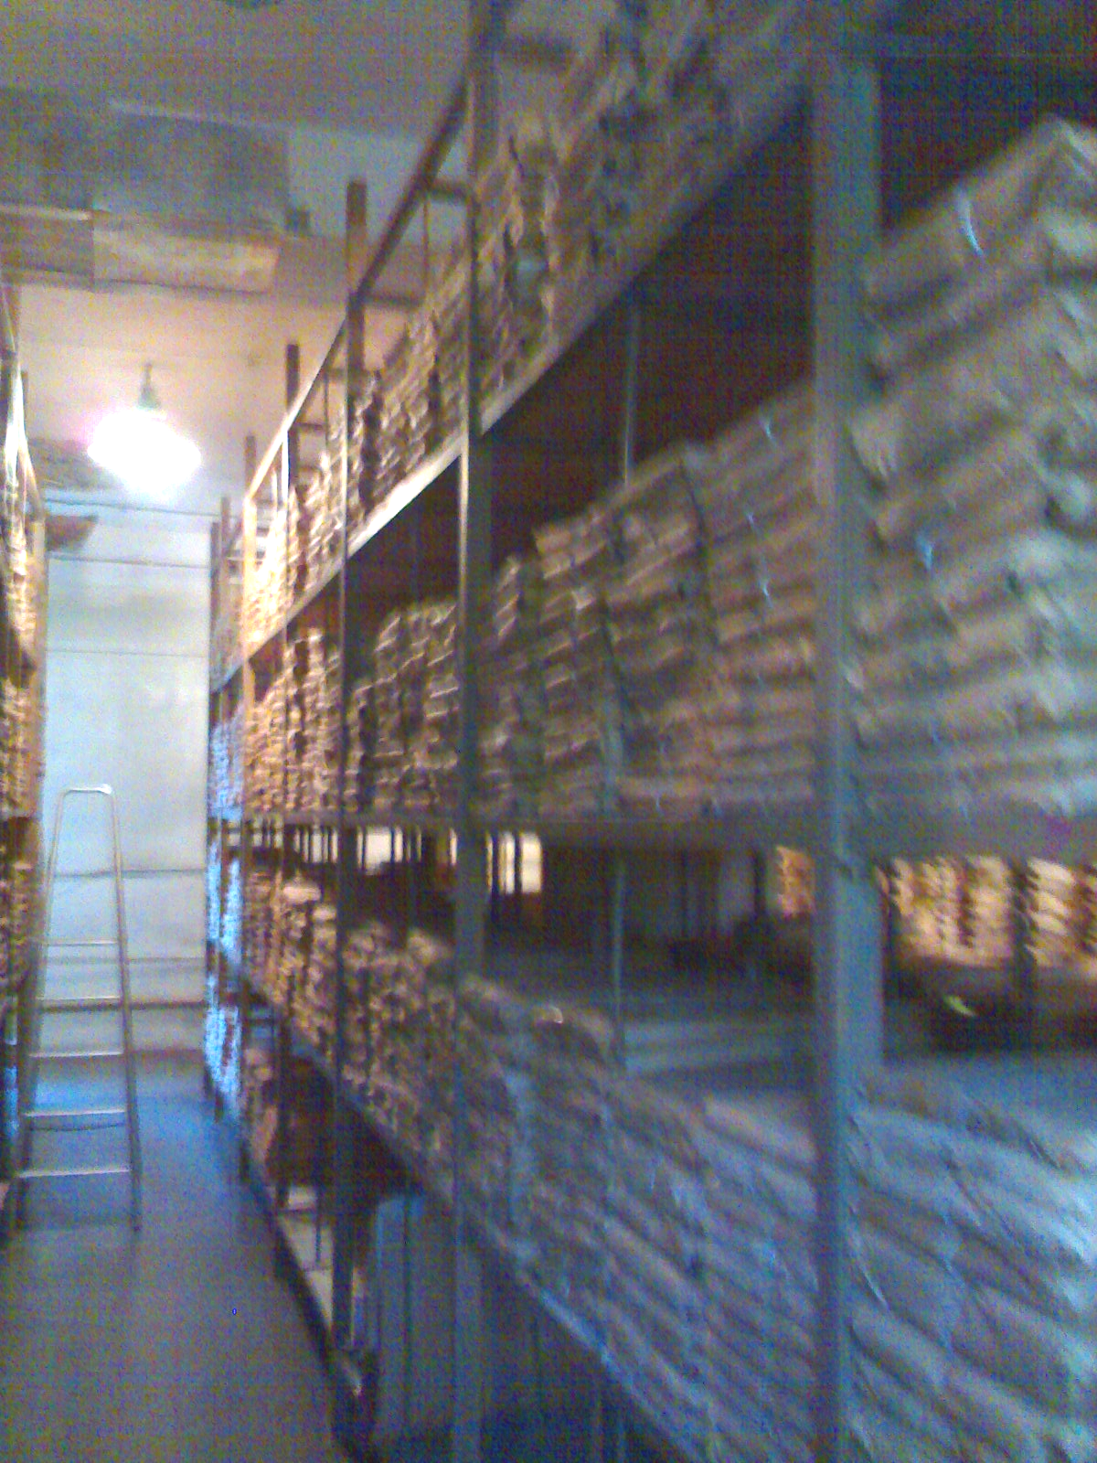

As no materials or data of the State Cartographical and Geodetic Foundation of the Russian Federation are subject to inclusion in the property of privatised organisations pursuant to art. 9 of Federal Law No. 209-FZ dated 26.12.1995 Geodesy and Cartography, there is no need to retain any enterprises subordinate to the Federal Agency of Geodesy and Cartography in the form of incorporation of a FGUP.
Therefore, it is time to lift restrictions of privatisation of state-owned Roskartographia enterprises.
On the one hand, functioning of state-owned Roskartographia enterprises in the modern organisational structure based on the governmental property has made it possible to retain the enterprise network and human resources, ensured access of the public to geodesy and cartography services and profitability of production in general as well as introduced components of commercialisation and marketing facilitating extension of the range of services offered.
Please note that the geodesy and cartography sector has a significant accelerated development potential. The sector has retained immense and unique brain capital and established bases for market institutes. Production infrastructure components are being developed and modernised. Most enterprises actively work under contracts with private sector companies without relying upon sufficient finance from the budget (Table 2).

Table 2
Parameters (roubles in million) | 2001 | 2002 | 2003 | 2004 | 2005 | 2006*
Proceeds | 1,514 | 2,365 | 2,660 | 2,826 | 3,555 | 5,016
Including:
State-financed work | 404 | 546 | 525 | 721 | 771 | 974
Contractual work | 983 | 1,713 | 1,987 | 2,105 | 2,784 | 4,042
Balance sheet profit | 203 | 303 | 220 | 266 | 482 | 510
* forecast
On the other hand, the existing form of management of federal state enterprises hinders development of market management principles, expanded reproduction, implementation of network functional management principles involving centralised and system solution of the industry-wide productive and economic objectives such as:
- full maintenance of resources;
- securing financial and economic conditions for operations in non-profit sectors of the market: sparsely populated areas and areas of severe climatic conditions;
- pursuing a common scientific, technical and pricing policy, and establishment of an automated data system of FGUP Roskartographia.
The existing management system has the following shortcomings:
- pursuance of short-term own results by regional organisations to the prejudice of long-term results of the sector as a whole;
- insufficient knowledge of the market condition across the nation and regions;
- inefficient utilisation of production resources;
- low level of responsibility of managers for financial and economic performance.
In addition, the state ownership of the means of production of FGUP Roskartographia and absence of the network unity as a property complex reduce attraction of FGUP Roskartographia as an investment and cast some doubt on their financial independence and competitiveness.
Competitiveness of services of FGUP Roskartographia in the information market, quality of service and inputs use efficiency largely depend on the quality condition and level of development of the physical infrastructure of the sector. Technical development and quality update of the economic potential is largely restricted by investment opportunities of the sector.
New construction and reconstruction of facilities of FGUP Roskartographia and re-equipment thereof are carried out from own funds of the enterprises, in particular, from their working capital. The share of own capital investment finance sources amounts to over 90 % of the aggregate amount of investments in the sector.
In general, the public sector of geodesy and cartography is efficient as evidenced by results of the recent years and good dynamic of financial performance. Alongside with that, the mechanisms used by managers of FGUPs subordinate to Roskartographia are clearly insufficient in the present conditions determined by the market economy.
Today, the main objective of efficient management of state property of the geodesy and cartography sector constitutes retaining and increasing the governmental property and accelerating positive processes in the sector. A tool for increasing enterprise efficiency may be a balanced and gradual modernisation of property relations with replacement of state property by property assigned to the FGUP on the economic control basis, rights of the government to a part of profit in the form of dividends and its participation in management (transformation into a joint stock company).
In view of the importance of the geodesy and cartography sector for the Russian Federation, positive and negative aspects of all possible options must be carefully analysed during selection of the option of transformation of the state-owned part of the sector into joint stock companies. We are still in a position to select the most efficient way of modernisation of property relations in the sector due to availability of many options.
In general, the Concept of governmental property management and privatisation in the Russian Federation, in preparation of which the author directly participated, researches and reflects all problems inherent to FGUPs comprehensively and in much detail.
According to the basic trends in privatisation of federal property in 2006-2008, all federal state unitary enterprises, which are not responsible for exercise of any state functions of the Russian Federation, will be offered for privatisation in 2007-2008.
The FGUP number reduction dynamic in the Russian Federation is as follows: there were 13,786 federal unitary enterprises in the Russian Federation in 1999 compared with 8,293 federal unitary enterprises in 2005. As of 1 June 2006, the Russian Federation was the owner of assets of 7,178 federal state unitary enterprises while on 1 January 2007 there were 6,533 FGUPs in the federal property register. Therefore, the number of FGUPs reduced by more than 50 per cent over 8 years (Chart 1). We believe that 6,000 federal enterprises at most will have remained by 1 June 2008.
Chart 1. Change in the number of FGUPs by years.
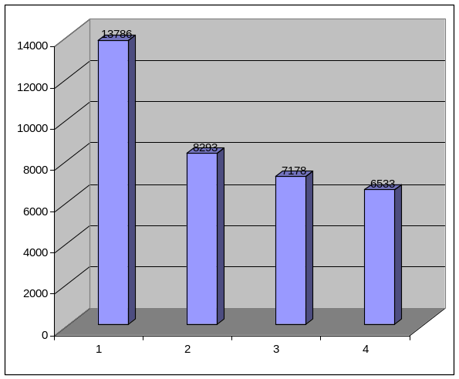

Many risks can be avoided in the event of transformation of an enterprise into a joint stock company as a unified complex with an open-ended transfer of 100 per cent of shares in the newly established business entity to the federal state property.
For example, the federal executive bodies will not lose control over the state-owned part of the sector, all lines of cartography and geodesy will be retained and will evolve and the amount of service will increase.
Note also that Roskartographia will continue to determine the growth directions, issue special permits for licensed activities, supervise, control and co-ordinate operations in the geodesy and cartography market while the largest market player will be a single business entity whose shares will be held by the Russian Federation that is also controlled by the Government.
We must note the benefits of centralisation of the basic functions and resources in the single business entity system. It becomes possible to build a hierarchy of managerial bodies of the open joint stock company (OAO) so established, which will be clear to all market players, and apply unified corporate management standards and approaches, which cannot be implemented in a FGUP. Only the scenario of transformation of the enterprise into a joint stock company as a unified complex will reduce the excess state control over the sector, retain the amount of assets necessary for the exercise of functions of governmental bodies in the federal property and create conditions for practical implementation of the private-public partnership principle widely used in other sectors.
The objective of such integrated enterprise is multiplication of enterprises’ potentials rather than simple addition of assets.
Controlling stakes in subsidiaries are contributed to the authorised capital of the parent company of the holding instead of 100 % shareholdings due to the imperative nature of provisions of paragraph 6 of article 98 of the Russian Federation Civil Code and paragraph 2 of article 10 of the Federal Joint Stock Company Law prohibiting a joint stock company from having as its sole member another business entity also having a single member. In this case, the sole member of subsidiaries is the parent company whose sole member, in turn, is the Russian Federation.
Certainly, establishment of a holding structure with a 100 % stake in the authorised capital of the subsidiary could efficiently minimise risks of loss of control over the sector and loss of property transferred to subsidiaries while organisation of control over operations of such subsidiaries would be of a purely technical nature. However, as already mentioned above, the applicable Russian legislation does not permit establishment of such a structure.
As a result, it is necessary to sell a part of shares in enterprises transformed into joint stock companies to third parties to implement the idea of such holding establishment together with retaining the influence of the Government subject to the privatisation legislation. The following shareholdings may be sold: up to 25 % (non-blocking shareholding) or from 25 % plus 1 share to 50 % minus 1 share (blocking shareholding). In the event of sale of a shareholding exceeding 50 % (controlling shareholding), establishment of such holding becomes senseless.
The privatisation practice proves that upon acquisition of a shareholding in a privatised enterprise a private shareholder strives to protect his investments, including by way of promoting and lobbying resolutions on completion of the privatisation. Therefore, there is an obvious threat of the government’s losing control over such enterprises in view of the generally low profitability of Roskartographia enterprises and attractiveness of the immovable property subordinate to them.
I propose the following option. Branches of the integrated business entity will be established on the basis of assets of reorganised Roskartographia enterprises, which branches will later be followed by its subsidiaries.
Establishment of branches seems to be a perfectly acceptable option for establishment of separate subdivisions of the integrated business entity instead of separate enterprises of Roskartographia. The head of any such branch may be vested with significant economic authorities and rights, including the right to sign financial and other documents on behalf of the integrated business entity thus providing him practically with an equivalent of the independent entity lost by him.
It is also worthy of note that unlike the option of subsidiary establishment, the integrated business entity shall be fully liable with all its property for operations of such branch as the latter is its internal organisation department. The integrated business entity is not directly liable for operations of its subsidiaries.
Another advantage of establishing branches on the basis of Roskartographia enterprises is the fact that such branches are subject to direct application of the administrative mechanisms of the integrated business entity. Such mechanism needs to be created with respect to subsidiaries.
However, a subsidiary is a fuller economic agent and may have a greater extent of responsibility and independence despite a number of important advantages of a branch. In terms of their functional capabilities, such structures are much more efficient than branches.
Resolution on establishment of subsidiaries is adopted after making an entry on registration of the integrated business entity in the Unified State Register of Legal Entities. Please note that establishment of subsidiaries after accumulation of property of federal state unitary enterprises of Roskartographia in an integrated business entity (rather than at the time of reorganisation) has a number of advantages.
First, it will make it possible to redistribute assets, that is to withdraw excess and surplus inefficiently used property and vest subsidiaries and affiliates with the resources required.
Second, the form of incorporation of such subsidiaries and affiliates may vary (OAO, ZAO or OOO) thus creating an additional tool for efficient management of the property complex of the integrated business entity. It is easier for the integrated business entity to secure control over a closed joint stock company or limited liability company than over an open joint stock company.
Third, the aforesaid forms of incorporation are better protected against investment expansion of competitors. It is also difficult to “outbid” control over a closed joint stock company or limited liability company due to the pre-emption right of shareholders/members of such companies to shares/interests alienated to third parties.
Fourth, it becomes possible to establish subsidiaries with attraction of private funds. In this case, article 105 of the Russian Federation Civil Code provides for fixing the “status” of a subsidiary both by virtue of the majority held by a legal entity in its authorised capital and by way of entering into appropriate contract between the legal entities. Therefore, there is a possibility for the integrated business entity to establish control over a future or existing legal entity without any financial investments.
See below the table analysing efficiency of different reorganisation options: integrated FGUP, integrated OAO and multiple OAO’s established on the basis of existing enterprises.
Advantages and disadvantages of different options

The case for the option | FGUP | OAO | A number of OAO’s
Absence of the need to change the form of incorporation | YES | NO | NO
Procedural and institutional merger of natural monopolistic and potentially competitive activities | YES | YES | NO
Increased monopolisation of the sector | YES | YES | NO
Risk of abuse due to concentration of influence on the sector in a single business entity | YES | YES | NO
Solution of the problem of the need for separation of economic and regulatory functions | NO | YES | YES
Increased motivation of employees | NO | YES | YES
Attractiveness for outward investments due to the possibility for outward investors to participate in the joint capital and company management | NO | YES | YES
Property title | NO | YES | YES
Increased influence of the government due to representation in the managerial bodies | NO | YES | YES
Possibility to attract private investments by selling shares in subsidiaries and bond issue | NO | YES | YES
Financial stability due to greater flexibility in assets disposal | NO | YES | YES
Distraction of management of the state-owned part of the sector with legal reorganisation | NO | YES | YES
Irreversibility of the governmental property alienation as a result of privatisation | NO | YES | YES
Risk of loss of stability of the state-owned part of the sector as a whole | NO | NO | YES
Possibility of efficient governmental control | NO | YES | NO

Decree No. 2284 of the Russian Federation President dated 24.12.1993 State Programme of Privatisation of State-Owned and Municipal Enterprises in the Russian Federation.
G. G. Pobedinsky, Report before the Board of Roskartographia dated 19.12.2006. Results of Regional Bodies of the Federal Agency of Geodesy and Cartography in 2006.
Source: Materials of the extended session of the Collegium of the Russian Ministry of Transport dated 13-14 March 2007 Main Results of Social and Economic Development of the Transportation Industry, Geodesy and Cartography in 2006 and Objectives for 2007 and Medium-Term Period until 2009.
Federal Law No. 39-FZ dated 22.04.1996 SECURITIES MARKET, Article 2. Share constitutes an equity security entitling its holder (shareholder) to a part of profits of the joint stock company in the form of dividends, participation in the joint stock company management and part of assets remaining after its liquidation.
Resolution No. 1024 of the RF Government dated 09.09.1999 CONCEPT OF GOVERNMENTAL PROPERTY MANAGEMENT AND PRIVATISATION IN THE RUSSIAN FEDERATION.
Resolution No. 1024 of the RF Government dated 09.09.1999 CONCEPT OF GOVERNMENTAL PROPERTY MANAGEMENT AND PRIVATISATION IN THE RUSSIAN FEDERATION.
FORECASTING SCHEDULE (PROGRAMME) OF FEDERAL PROPERTY PRIVATISATION FOR 2006 AND BASIC TRENDS OF FEDERAL PROPERTY PRIVATISATION IN 2006-2008. Approved by resolution No. 1306-p of the Russian Federation Government dated 25 August 2005.
FORECASTING SCHEDULE (PROGRAMME) of federal property privatisation for 2006 and basic trends of federal property privatisation in 2007-2009. APPROVED by resolution No. 1184-p of the Russian Federation Government dated 25 August 2006.
V. L. Nazarov. Industry Concepts Needed. Business Journal: Organisation, Strategy, Systems No. 3 2007.

